Answer for task 3:
1. CREATE DATABASE
CREATE DATABASE eventsmanagement;
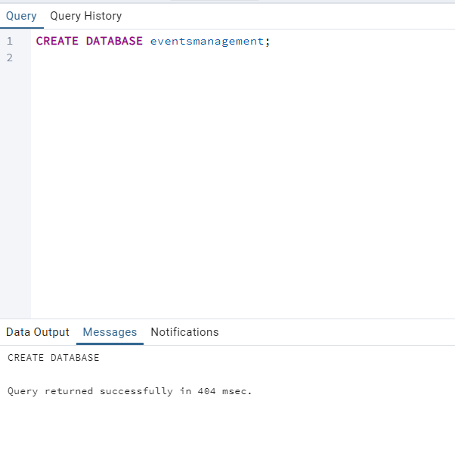

2. CREATE TABLES
CREATE TABLE events (
event_id INT PRIMARY KEY,
event_name TEXT,
event_date DATE,
event_location TEXT,
event_description TEXT
);

CREATE TABLE attendees (
attendee_id INT PRIMARY KEY,
attendee_name TEXT,
attendee_phone TEXT,
attendee_email TEXT,
attendee_city TEXT
);

CREATE TABLE registrations (
registration_id INT PRIMARY KEY,
event_id INT,
attendee_id INT,
registration_date DATE,
registration_amount NUMERIC,
FOREIGN KEY (event_id) REFERENCES events(event_id),
FOREIGN KEY (attendee_id) REFERENCES attendees(attendee_id)
);

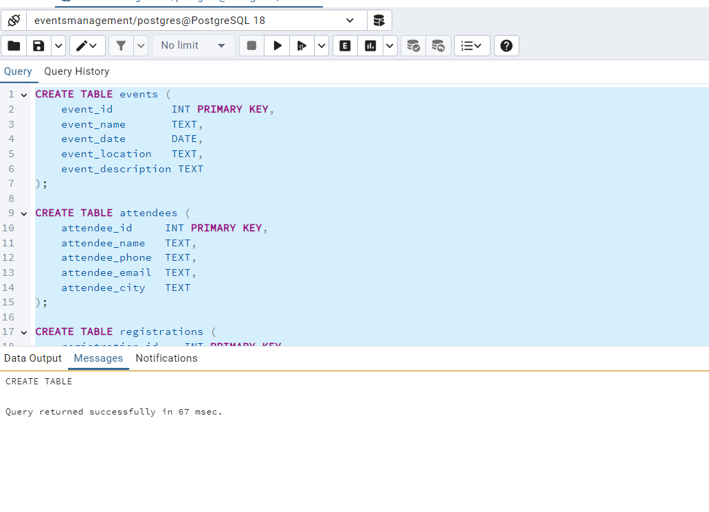

3. INSERT SAMPLE DATA

INSERT INTO events VALUES
(1, 'Tech Summit 2025', '2025-02-10', 'Delhi', 'Technology and innovation event'),
(2, 'Music Fest', '2025-03-15', 'Mumbai', 'Live music concert'),
(3, 'Startup Expo', '2025-04-20', 'Bangalore', 'Startup showcase and networking');

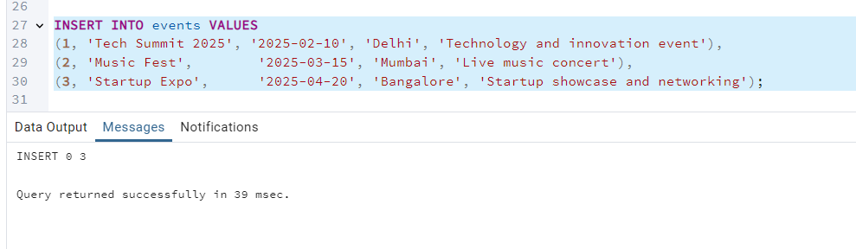
3.2 Insert Attendees
INSERT INTO attendees VALUES
(1, 'Aman Kumar', '9871111111', 'aman@example.com', 'Delhi'),
(2, 'Sara Malik', '9872222222', 'sara@example.com', 'Mumbai'),
(3, 'Rohit Sharma','9873333333', 'rohit@example.com', 'Bangalore'),
(4, 'Priya Verma', '9874444444', 'priya@example.com', 'Delhi');

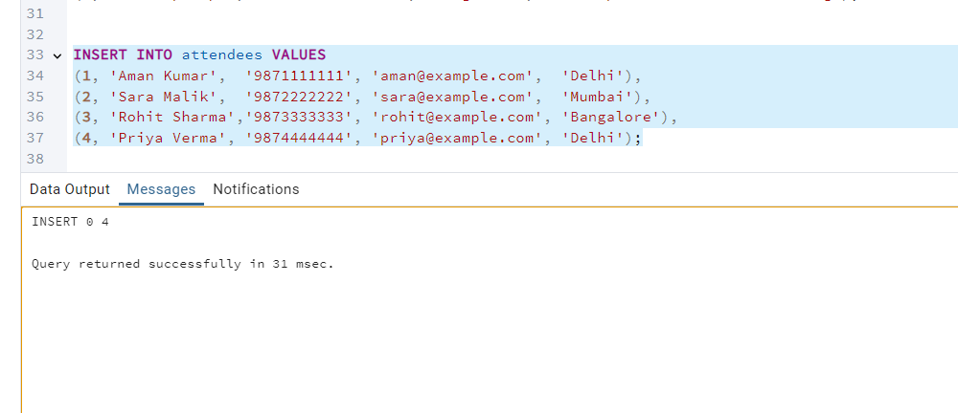

3.3 Insert Registrations

INSERT INTO registrations VALUES
(101, 1, 1, '2025-01-15', 500),
(102, 1, 4, '2025-01-20', 500),
(103, 2, 2, '2025-02-10', 800),
(104, 3, 1, '2025-03-01', 600),
(105, 3, 3, '2025-03-05', 600);

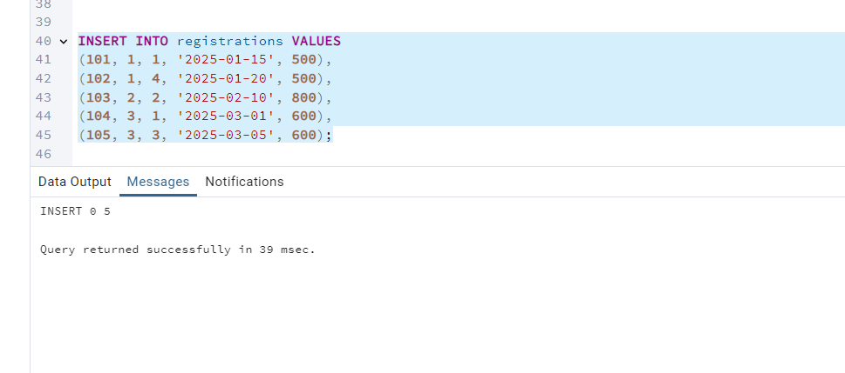

4. MANAGE EVENT DETAILS

INSERT INTO events VALUES
(4, 'Health Conference', '2025-05-10', 'Chennai', 'Medical and wellness conference');

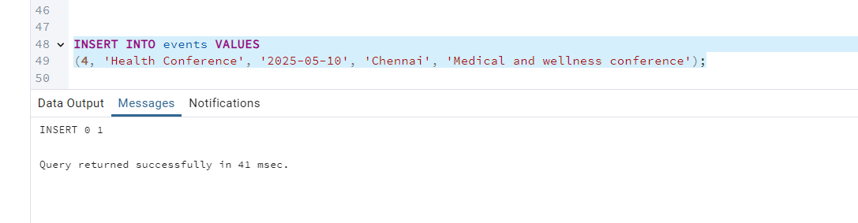

4B. Update an event’s information

UPDATE events
SET event_location = 'Hyderabad',
event_date = '2025-02-20'
WHERE event_id = 1;

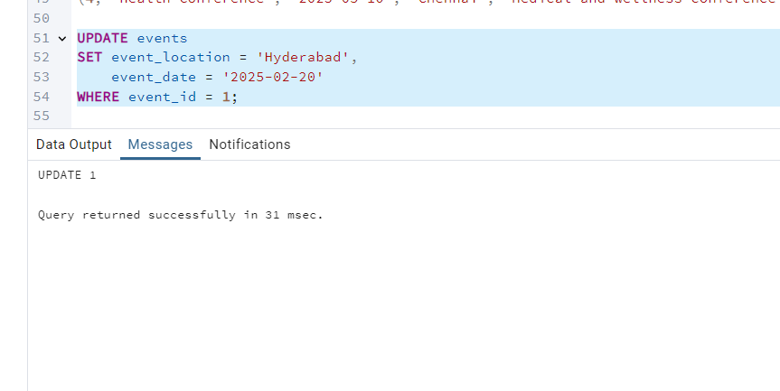

4C. Delete an event

DELETE FROM events
WHERE event_id = 2;

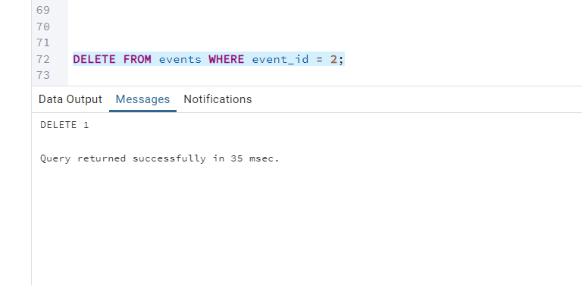

5. MANAGE ATTENDEES & REGISTRATIONS
5A. Insert a new attendee
INSERT INTO attendees VALUES
(5, 'Neha Sharma', '9879999999', 'neha@example.com', 'Kolkata');

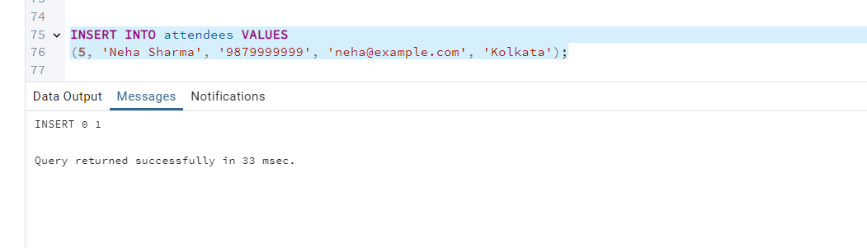

5B. Register an attendee for an event
INSERT INTO registrations VALUES
(106, 1, 5, '2025-02-01', 500);

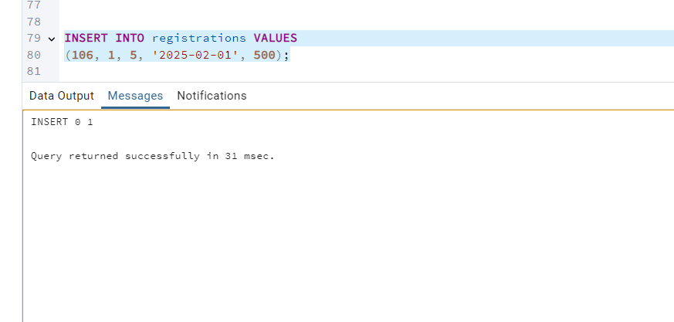
6. EVENT INFORMATION & REPORTS
6A. Retrieve all event details

SELECT * FROM events;

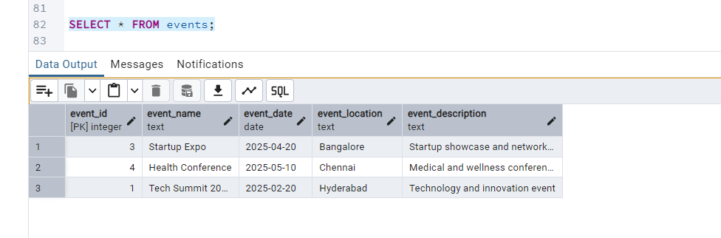

6B. Generate attendee list for a specific event
(Example: event_id = 1)

SELECT
e.event_name,
a.attendee_name,
a.attendee_email,
r.registration_date
FROM registrations r
JOIN attendees a ON r.attendee_id = a.attendee_id
JOIN events e ON r.event_id = e.event_id
WHERE r.event_id = 1;

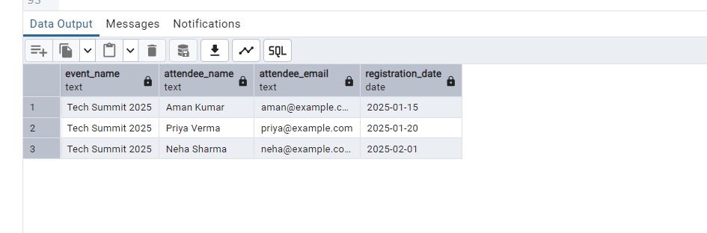

6C. Calculate event attendance statistics
(Count of attendees per event)

SELECT
e.event_name,
COUNT(r.attendee_id) AS total_attendees
FROM events e
LEFT JOIN registrations r ON e.event_id = r.event_id
GROUP BY e.event_name;
